**Week 7:**

Create an application for Layout widgets (Single child, Multiple Child).

**Flutter Layouts**

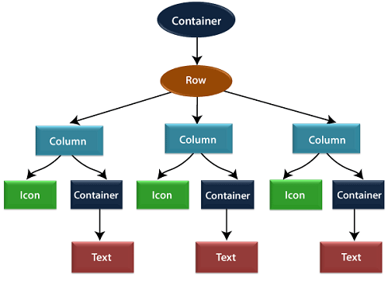

## Layout a widget

Let us learn how we can create and display a simple widget. The following steps show how to layout a widget:

**Step 1:** First, you need to select a Layout widget.

**Step 2:** Next, create a visible widget.

**Step 3:** Then, add the visible widget to the layout widget.

**Step 4:** Finally, add the layout widget to the page where you want to display.

## Types of Layout Widgets

We can categories the layout widget into two types:

1. Single Child Widget
2. Multiple Child Widget

# Container:

import 'package:flutter/material.dart';  
  
void main()

{  
 runApp(MyApp());  
}  
  
class MyApp extends StatelessWidget

{  
 @override  
 Widget build(BuildContext context)

{  
 return MaterialApp(  
 home: Scaffold(  
 appBar: AppBar(  
 title: Text('Container Example'),  
 ),  
 body: Center(  
 child: Container(  
 width: 200,  
 height: 200,  
 color: Colors.blue,  
 child: Center(  
 child: Text(  
 'Hello, Flutter!',  
 style: TextStyle(  
 color: Colors.white,  
 fontSize: 20,  
 ),  
 ),  
 ),  
 ),  
 ),  
 ),  
 );  
 }  
}

**OUTPUT:**

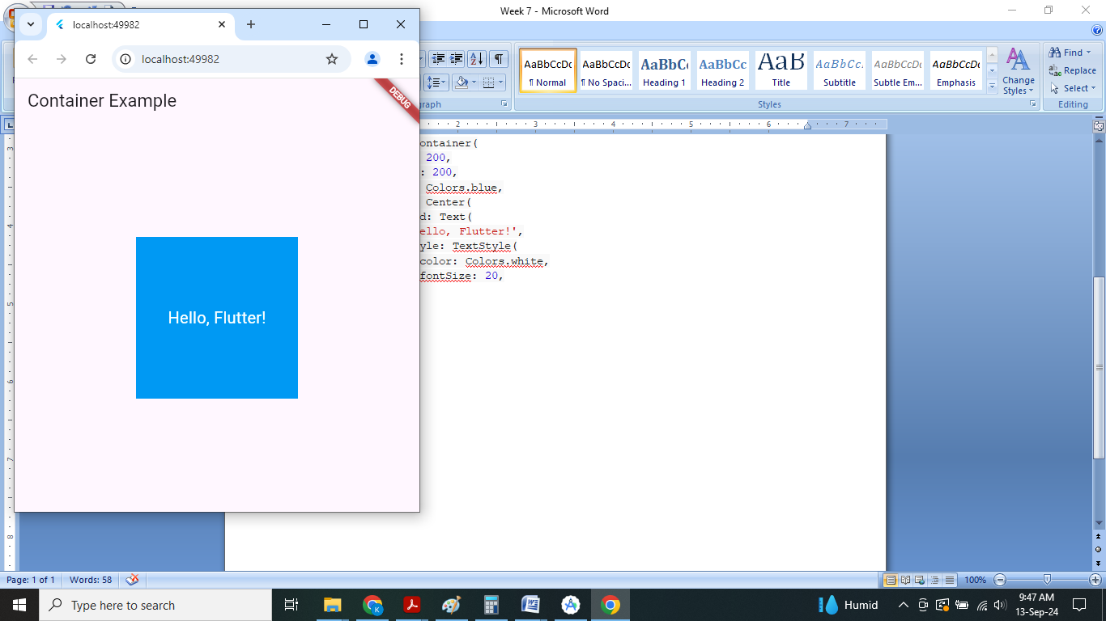

# Grid View:

# import 'package:flutter/material.dart';

# class GridViewExample extends StatelessWidget

# {

# @override

# Widget build(BuildContext context)

# {

# return Scaffold(

# appBar: AppBar(

# title: Text('GridView Example'),

# ),

# body: GridView.count(

# crossAxisCount: 3, // Number of columns in the grid

# children: List.generate(9, (index) {

# // Generate 9 grid items

# return Center(

# child: Container(

# decoration: BoxDecoration(

# color: Colors.blue[100 * (index % 9)],

# border: Border.all(),

# ),

# padding: EdgeInsets.all(20.0),

# child: Text(

# 'Item $index',

# style: TextStyle(fontSize: 20.0),

# ),

# ),

# );

# }),

# ),

# );

# }

# }

# void main()

# {

# runApp(MaterialApp(

# home: GridViewExample(),

# ));

# }

# OUTPUT

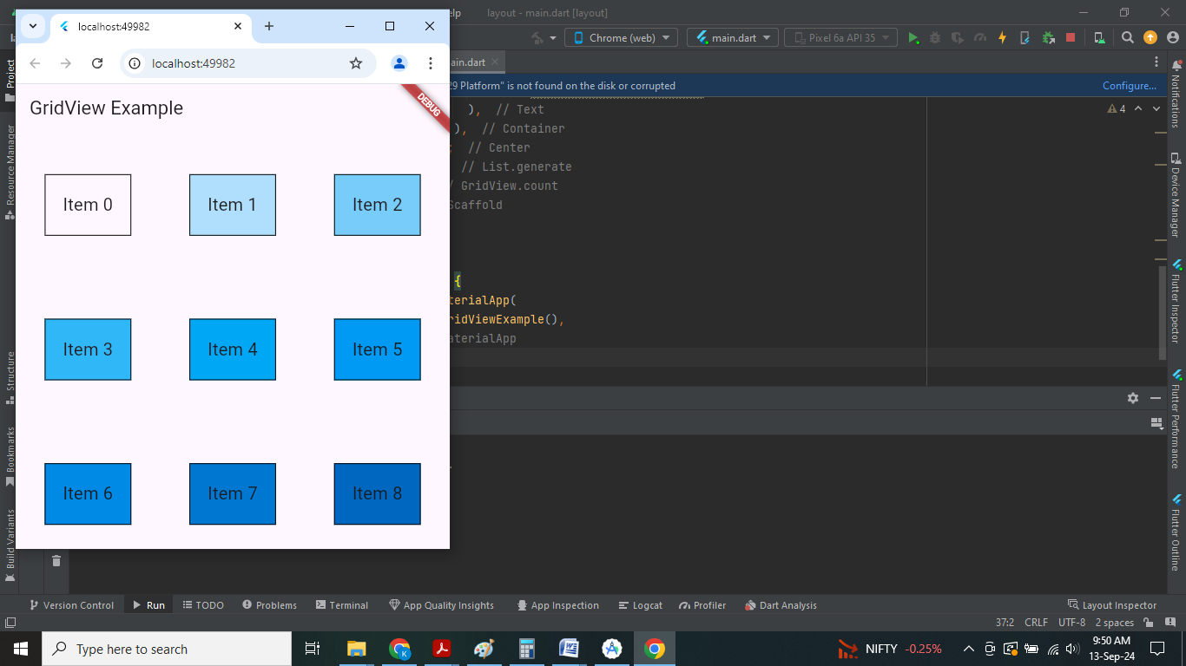

# List View:

import 'package:flutter/material.dart';

class ListViewExample extends StatelessWidget

{

@override

Widget build(BuildContext context)

{

return Scaffold(

appBar: AppBar(

title: Text('ListView Example'),

),

body: ListView(

children: List.generate(20, (index) {

// Generate 20 list items

return ListTile(

leading: Icon(Icons.person),

title: Text('Item $index'),

subtitle: Text('Subtitle for Item $index'),

onTap: () {

// Action when item is tapped

print('Item $index tapped');

},

);

}),

),

);

}

}

void main()

{

runApp(MaterialApp(

home: ListViewExample(),

));

}

**OUTPUT**

